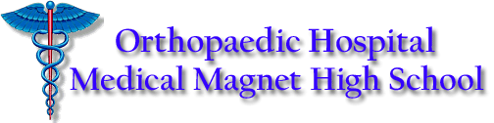
NAME: _____________________________________ DATE: ____________________
Expository Composition 12B Ms. Ciuperca

BRAVE NEW WORLD vs. OUR WORLD
In Brave New World, Aldous Huxley creates a utopia, defined as a perfect society that does not exist. Usually, writers use their imagination to express their criticism or praise of something that exists, by removing or changing it in a utopian/dystopian way.
Take a minute to look at the following habits of the New World Huxley has created and think of a possible habit/concept that exists in our world and how Huxley may be criticizing it in his novel:
Concept/Habit of the New World | Characters’ opinion of it/ how is it viewed in the New World and why? | Parallel habit / concept of our world | How is it criticized in the novel?
Birth / Conditioning at birth

Dividing the world into social classes

Home / motherhood

Soma (drugs)

Children playing erotic games

“Everyone belongs to everyone else”

“Ending is better than mending”

Epsilons are conditioned to hate books

Epsilons are conditioned to hate nature

Moral education is done through sleep-teaching

Participation in an orgy is mandatory of each citizen

Phosphorous is recovered from cremated bodies and used to fertilize plants

Each cast is conditioned to hate the others and be happy where they are on the social scale.

Gammas are injected alcohol into their blood surrogate to stunt their physical growth

