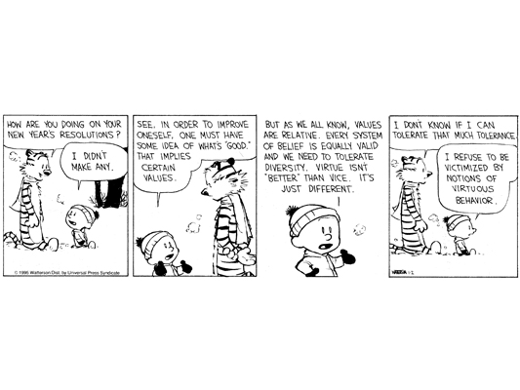

NAME: _____________________________________ DATE: ____________________
Composition 11/12B Ms. Ciuperca
Claims

1. What is Calvin's overall argument? Focusing on Calvin's discussion of values, virtues, and "what's good," list all of the claims that Calvin uses to make his argument. For each claim, include whether it is implicit or explicit and the type of claim that it is (e.g., a claim of definition).
____________________________________________________________________________________________________________________________________________________________________________________________________
2. Pick two claims of different types that you identified in question 1. How does each claim work separately to advance Calvin's argument? How do they work together to advance Calvin's argument? In this instance, is one type of claim more effective than the other? Why or why not?
________________________________________________________________________________________________________________________________________________________________________________________________________________________________________________________________________________________________________________________________________________________________________________________________________
3. Which types of claims does Calvin not use? Which of these omitted types might have been used to strengthen his argument? How?

____________________________________________________________________________________________________________________________________________________________________________________________________

